### Current Activities

The museum curators have continued in “consolidation mode”, with more tidying up and cataloguing. We have just taken delivery of a quantity of plastic containers so that we can start cataloguing and storing a quantity of CE tools and spare parts.

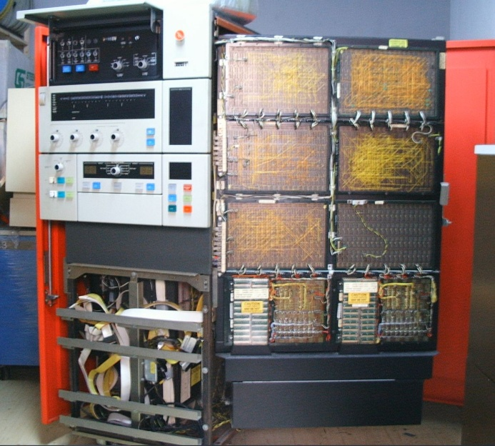

We have been offered the opportunity of a fully working System/3 Model 10, which the owner would like it to go to a dedicated IBM museum. System/3 is of special interest as the disk drives are the 5444 Dolphin, developed in Hursley. We have worked out that we have space to display this, and are now looking at costs involved in shipping from Europe. As usual the problem is likely to be funding, but first we need to understand how much.

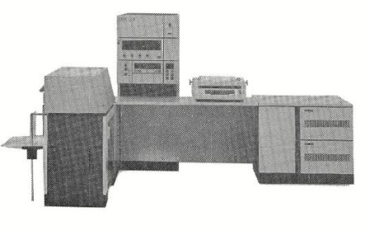

### Trifolds

We’ve now made the museum’s trifolds available on the web site so people can print their own, and are thinking about a new trifold on CICS.

### Other

Peter Short has put together a ‘starter’ list of hardware built in Greenock for the people planning to make a documentary about “Silicon Glen” with a main focus on IBM’s Spango Valley plant. They may be able to expand this as they continue their research. The museum has also offered access to film some of the machines we have with ‘origin 55’, the Greenock code within hardware serial numbers. It has now gone very quiet.

Our contribution to the BBC’s Y2K segment on the One Show was not used. We were rather disappointed that the BBC slant was almost that there wasn’t really a problem, it was largely hype. The programme was broadcast Monday 6th January.